MINI PROJECT REPORT

Project Title:
Battleship Game Using C Programming

TITLE PAGE

Subject: Foundation of programming

Submitted By:
- Vardhini – 1262251614
- Siddhi – 1262252838
- Samiksha – 1262253498
- Atulya – 1262253632
- Siddhant – 1262250504

Project Guide:
Dr. Anushri Kulkarni

Institution Name:
MIT-WPU

TABLE OF CONTENTS

- Title Page …….………………………………………………1
- Acknowledgement ....…….……………………………………………3
- Abstract .….………………… ……………………………..3
- Table of Contents ………………………………………………………2
- List of Figures ..……………………………..………………………………4
- List of Tables …………………,,…………..………………………………4
- 1. INTRODUCTION ..………………………………………………………………5
- 2. PROBLEM STATEMENT ………………………………..………………………………5
- 3. OBJECTIVES …………………………………………………………………6
- 4. LITERATURE REVIEW …………………………………………………………………6
- 5. SYSTEM DESIGN AND METHODOLOGY ……………………………………………………7
  - 5.1 Overall Design Approach ………………………………………………….8
  - 5.2 Board Representation ………………………………………………….9
  - 5.3 Algorithms ………………………………………………….9
- 6. IMPLEMENTATION …………………………………………………10
- 7. TESTING ………………………………………………..12
- 8. RESULTS AND DISCUSSION ………………………………………………..12
- 9. CONCLUSION ………………………………………………..13
- 10. FUTURE SCOPE ………………………………………………..13
- 11. REFERENCES ………………………………………………..13

ACKNOWLEDGEMENT
We would like to express our sincere gratitude to our respected project guide for their continuous guidance, encouragement, and valuable suggestions throughout the development of this project. Their support helped us understand the practical implementation of programming concepts beyond theoretical learning.
We also thank the faculty members of the Computer Science department for providing us with the necessary knowledge and technical foundation required to complete this project successfully. The concepts taught in the Foundations of Programming course were essential in designing and implementing this system.
We are equally thankful to our teammates for their cooperation, teamwork, and dedication during the project development process. This project would not have been possible without collaborative effort and effective communication among team members.

ABSTRACT
This project presents the design and implementation of a console-based Battleship game using the C programming language. Battleship is a strategic naval warfare game in which players attempt to locate and destroy the opponent’s ships placed on a grid. The objective of this project is to implement a Player vs Computer version of the game using fundamental programming concepts.
The system utilizes 2D arrays to represent the game boards of both the player and the computer. Ships are placed randomly using random number generation techniques, and validation logic ensures proper placement without overlapping. The game follows a turn-based mechanism where the player and computer alternate turns until all ships of one side are destroyed.
The project demonstrates the practical application of arrays, loops, conditional statements, modular programming using functions, and logical decision-making structures. The successful implementation of this system enhances understanding of structured programming and algorithm design in C.

LIST OF FIGURES
Figure 1: Flowchart of Game Logic
On Page 8

LIST OF TABLES

Table 1: Testing Scenarios and Results

Test Case | Input | Expected Output | Actual Output | Result
Valid Shot | B4 | Hit/Miss | Hit/Miss | Passed
Invalid Input | Z9 | Error | Error | Passed
Repeat Shot | Same Cell | Already fired | Already fired | Passed
Win Condition | All Ships Destroyed | Winner | Winner | Passed

1. INTRODUCTION
Battleship is a classic strategy-based naval warfare game where players attempt to sink the opponent’s ships by guessing their positions on a grid. The game requires logical thinking, prediction, and strategic planning. Traditionally played as a board game, it has evolved into digital formats implemented using various programming languages.
The purpose of implementing Battleship in C is to apply foundational programming concepts in a practical scenario. C is a structured programming language that emphasizes logic building and memory efficiency. Developing a game using C strengthens understanding of arrays, loops, functions, and conditional statements.
This project focuses on creating a console-based version of Battleship where a player competes against the computer. The game is played on an 8×8 grid. Ships of different lengths are placed randomly on the board. The player enters coordinates such as B4 or C5 to attack the opponent’s grid. Hits are marked with ‘X’, misses with ‘O’, ships with ‘S’, and water with ‘~’.
Through this project, theoretical concepts are transformed into practical implementation. It enhances logical reasoning and provides experience in problem-solving and debugging.

2. PROBLEM STATEMENT
The objective of this project is to design and implement a console-based Battleship game using C programming that ensures:
- Proper and non-overlapping ship placement
- Accurate input validation
- Correct hit and miss detection
- Efficient turn-based gameplay
- Accurate winner determination
The system must function reliably within a console environment while maintaining structured programming practices.

3. OBJECTIVES
- To represent game boards using 2D arrays
- To implement modular programming using functions
- To use random number generation for ship placement
- To validate and process user input
- To simulate turn-based game logic
- To strengthen logical problem-solving skills

4. LITERATURE REVIEW
Game development has long been used as a practical tool for teaching programming fundamentals. Research in computer science education suggests that interactive games improve engagement and logical reasoning among students. Console-based games are particularly effective for beginners as they emphasize algorithm design rather than graphical complexity.
Several simple games such as Tic-Tac-Toe, Snake Game, and Minesweeper have been implemented using procedural programming languages like C and C++. These implementations commonly use 2D arrays to represent grid structures and loops to control gameplay flow.
Studies indicate that modular programming improves readability, debugging efficiency, and maintainability of code. Functions allow separation of tasks such as initialization, validation, and result computation. Random number generation is widely used in game development to introduce unpredictability and fairness.
Compared to advanced game engines, console-based implementations focus more on logical structuring and algorithm development. This project aligns with foundational programming objectives by emphasizing structured coding practices rather than graphical user interface development.

5. SYSTEM DESIGN AND METHODOLOGY

5.1 Overall Design Approach
The game uses two 8×8 character matrices to represent the boards of the player and the computer. Each matrix stores symbols representing water, ships, hits, and misses.
Game Flow:
- Initialize both boards.
- Randomly place ships.
- Display boards.
- Player fires at computer board.
- Computer fires at player board.
- Check winner.
- Repeat until game ends.

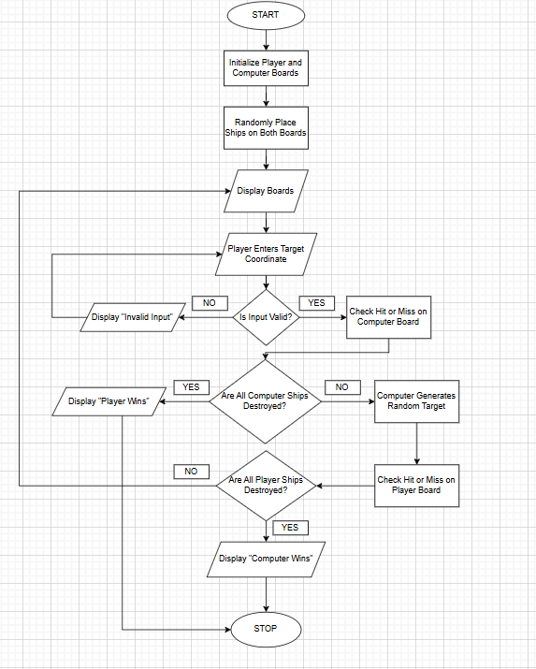

5.2 Board Representation
The board is implemented using:
char board[8][8];
This allows row and column indexing. Rows are labeled A–H and columns 1–8 for user-friendly coordinate input.

5.3 Algorithms

Ship Placement Algorithm
- Generate random row and column.
- Generate random direction.
- Check boundary conditions.
- Check overlapping condition.
- Place ship if valid.

Firing Algorithm
- Accept coordinate input.
- Convert into index.
- Check symbol.
- Update board.
- Display result.

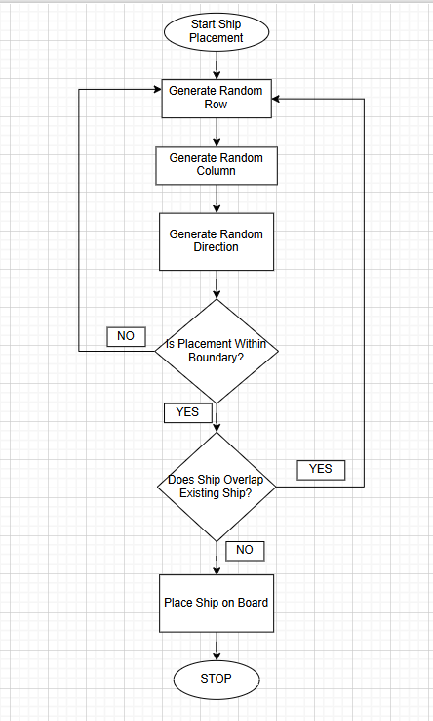

6. IMPLEMENTATION

The project is implemented using modular functions.

init()
placeAllShips()
print()
fire()
rem
Main

init()
Initializes the board with water symbol.
print()
Displays board with formatting and optional ship hiding.
canPlace()
Ensures ships do not overlap and remain within boundaries.
placeShip()
Places individual ships randomly.
fire()
Processes player or computer attack.
remaining()
Counts remaining ship parts.

7. TESTING

Table 1: Testing Scenarios and Results
Test Case | Input | Expected Output | Actual Output | Result
Valid Shot | B4 | Hit/Miss | Hit/Miss | Passed
Invalid Input | Z9 | Error | Error | Passed
Repeat Shot | Same Cell | Already fired | Already fired | Passed
Win Condition | All Ships Destroyed | Winner | Winner | Passed

Additional boundary and logical tests were performed to ensure system stability.

8. RESULTS AND DISCUSSION
The Battleship game executed successfully in a console environment. Ships were placed randomly without overlapping due to validation logic. The player and computer alternated turns correctly.
The system accurately detected hits and misses and updated the board dynamically. The winning condition was correctly implemented using a ship-counting function.

9. CONCLUSION
The project successfully implemented a console-based Battleship game using C programming. It demonstrated effective use of arrays, loops, conditionals, and modular programming techniques.
The project enhanced understanding of matrix operations and algorithm design. It serves as a strong foundation for future advanced software development projects.

10. FUTURE SCOPE
- Add Player vs Player mode
- Implement intelligent AI strategy
- Add difficulty levels
- Develop graphical interface
- Add score tracking system
- Include sound effects

11. REFERENCES
- B. W. Kernighan and D. M. Ritchie
- The C Programming Language
- 2nd ed., Prentice Hall.

